**MicroTAS 2025 CONFERENCE TEMPLATE FOR TECH TALK EXPRESSIONS OF INTEREST**

Industry Speaker1 and Collaborator2

1Company One, COUNTRY

2Institution Two, COUNTRY

The Twenty Ninth International Conference on Miniaturized Systems for Chemistry and Life Sciences (µTAS) will be held 2 - 6 November 2025 in Adelaide, Australia. ***Industry Sponsors are invited to contribute Tech Talks for the first time.***Tech Talks must inform conference attendees of scientific or technical advances, case studies, or new technologies that are relevant and important to the µTAS community (see conference topics, including Hot Topics). It is appreciated that Sponsors may use the presentation to highlight their products or services where relevant to the scientific or technical content being presented. However, purely promotional or marketing content is strongly discouraged. Tech Talks will be presented during the technical program in a relevant session. See Table 1 for an example (time and day of Tech Talks will be confirmed in the final program).

Submitted EOIs should be up to two pages: one text page (500 words or less, 11-point font) and one page of figures and tables on either A4 Standard (21 cm x 29.7 cm) or US Standard (8.5 x 11 inches). The title, topic (selected from the category listing), authors, affiliations and all text must fit on the first page. The second page should contain all figures or tables. References[1-3] may go on either page.

The purpose of an EOI submitted to µTAS 2025 is to inform the SpEx Committee which technical or scientific capability you propose to present. Your EOI will be used to align Tech Talks with accepted technical abstracts to create a thematic grouped session. Please state what your primary technical or scientific focus is within the first few sentences. For example: "This paper reports a new self-priming pump for the pulse-less delivery of fluid that can be used for continuous cell culture”. It is also important to identify how the new work is highly relevant to the target audience; µTAS attendees. For example: "Although many pumps suffer from pulsed flow, our self-priming pumps can provide pulse-free flow (<1% variation in flow rate) for long periods of time (>1 h)." Accepted EOIs will be published within the technical program.

After an introduction of the basic ideas and how the work relates to other work, please describe the technical advances and the application, including Figures and Tables for support. For example: "A schematic view of the chip is shown in Figure 1. Data collected over 7 days is shown in Figure 2 and 3.”. Conclude with a clear statement of the opportunities and benefits of using this technology to the µTAS community.

Please make sure that all the figures/photographs are clearly visible. If the program committee cannot clearly see and understand the role of visual aids, your abstract will be viewed negatively. All submitted EOIs will be considered for Tech Talk oral presentations, but Sponsors are limited to one Tech Talk in the program. Acceptance will be based on committee ranking and alignment with the scientific program.

Word Count: 500

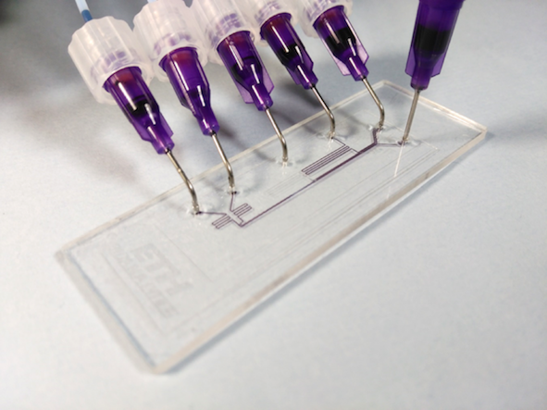

*Figure 1: Photograph of the chip xxx in 300 dpi*

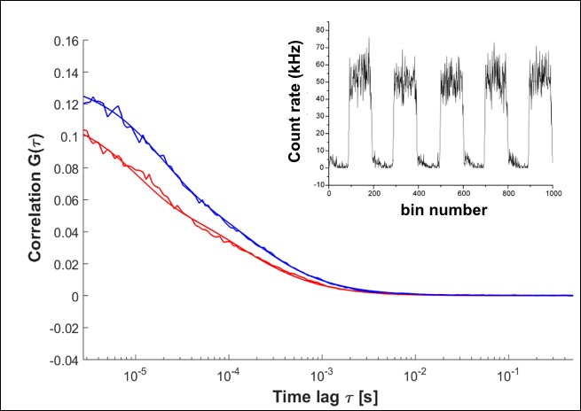

*Figure 2: DATA, Results of xxxxxxxxxx*

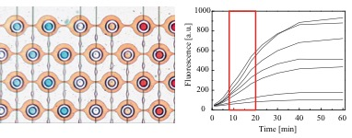

*Figure 3. Chip design and results obtained for xxx*

*Table 1: An example of Tech Talk inclusion in the Technical Program*

|  |  |  |
| --- | --- | --- |
| *10:00\** | *Break* | |
| *10:20* | *Keynote Talk* | *Invited Speaker* |
| ***10:40*** | ***Tech Talk*** | ***Sponsor Speaker*** |
| *11:00* | *Accepted Oral* | *Speaker* |
| *11:15* | *Accepted Oral* | *Speaker* |
| *11:30* | *…* | *…* |

*\*Times are for illustration purposes only.*

**REFERENCES**

1. Manz, A., Graber, N., Widmer, H. M., "Miniaturized Total Chemical Analysis Systems: A Novel Concept for Chemical Sensing," *Sensors and Actuators B: Chemical*, 1990, **1**, 244 .
2. Whitesides, G.M. “The Origin and Future of Microfluidics,” *Nature*, 2006, **442**, 368.

3. Terry, S. C. , “A Gas Chromatography System Fabricated on A Silicon Wafer Using Integrated Circuit Technology,” PhD thesis Stanford University (USA), 1975.